Seven Initial Drawing Lessons
For Primary Students

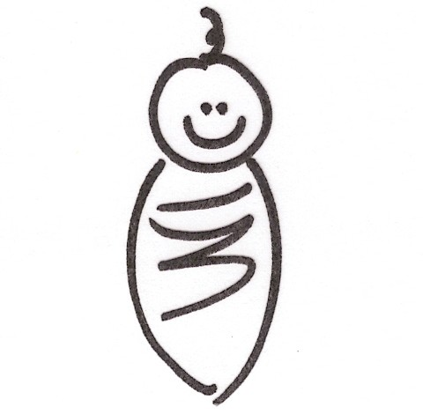

Ted DeMille
Center for Teaching and Learning
Edgecomb, Maine
2008

© 2008 by Ted DeMille. Making Believe on Paper. Heinemann: Portsmouth, NH.

Lesson One: Common Shapes Used for Drawing
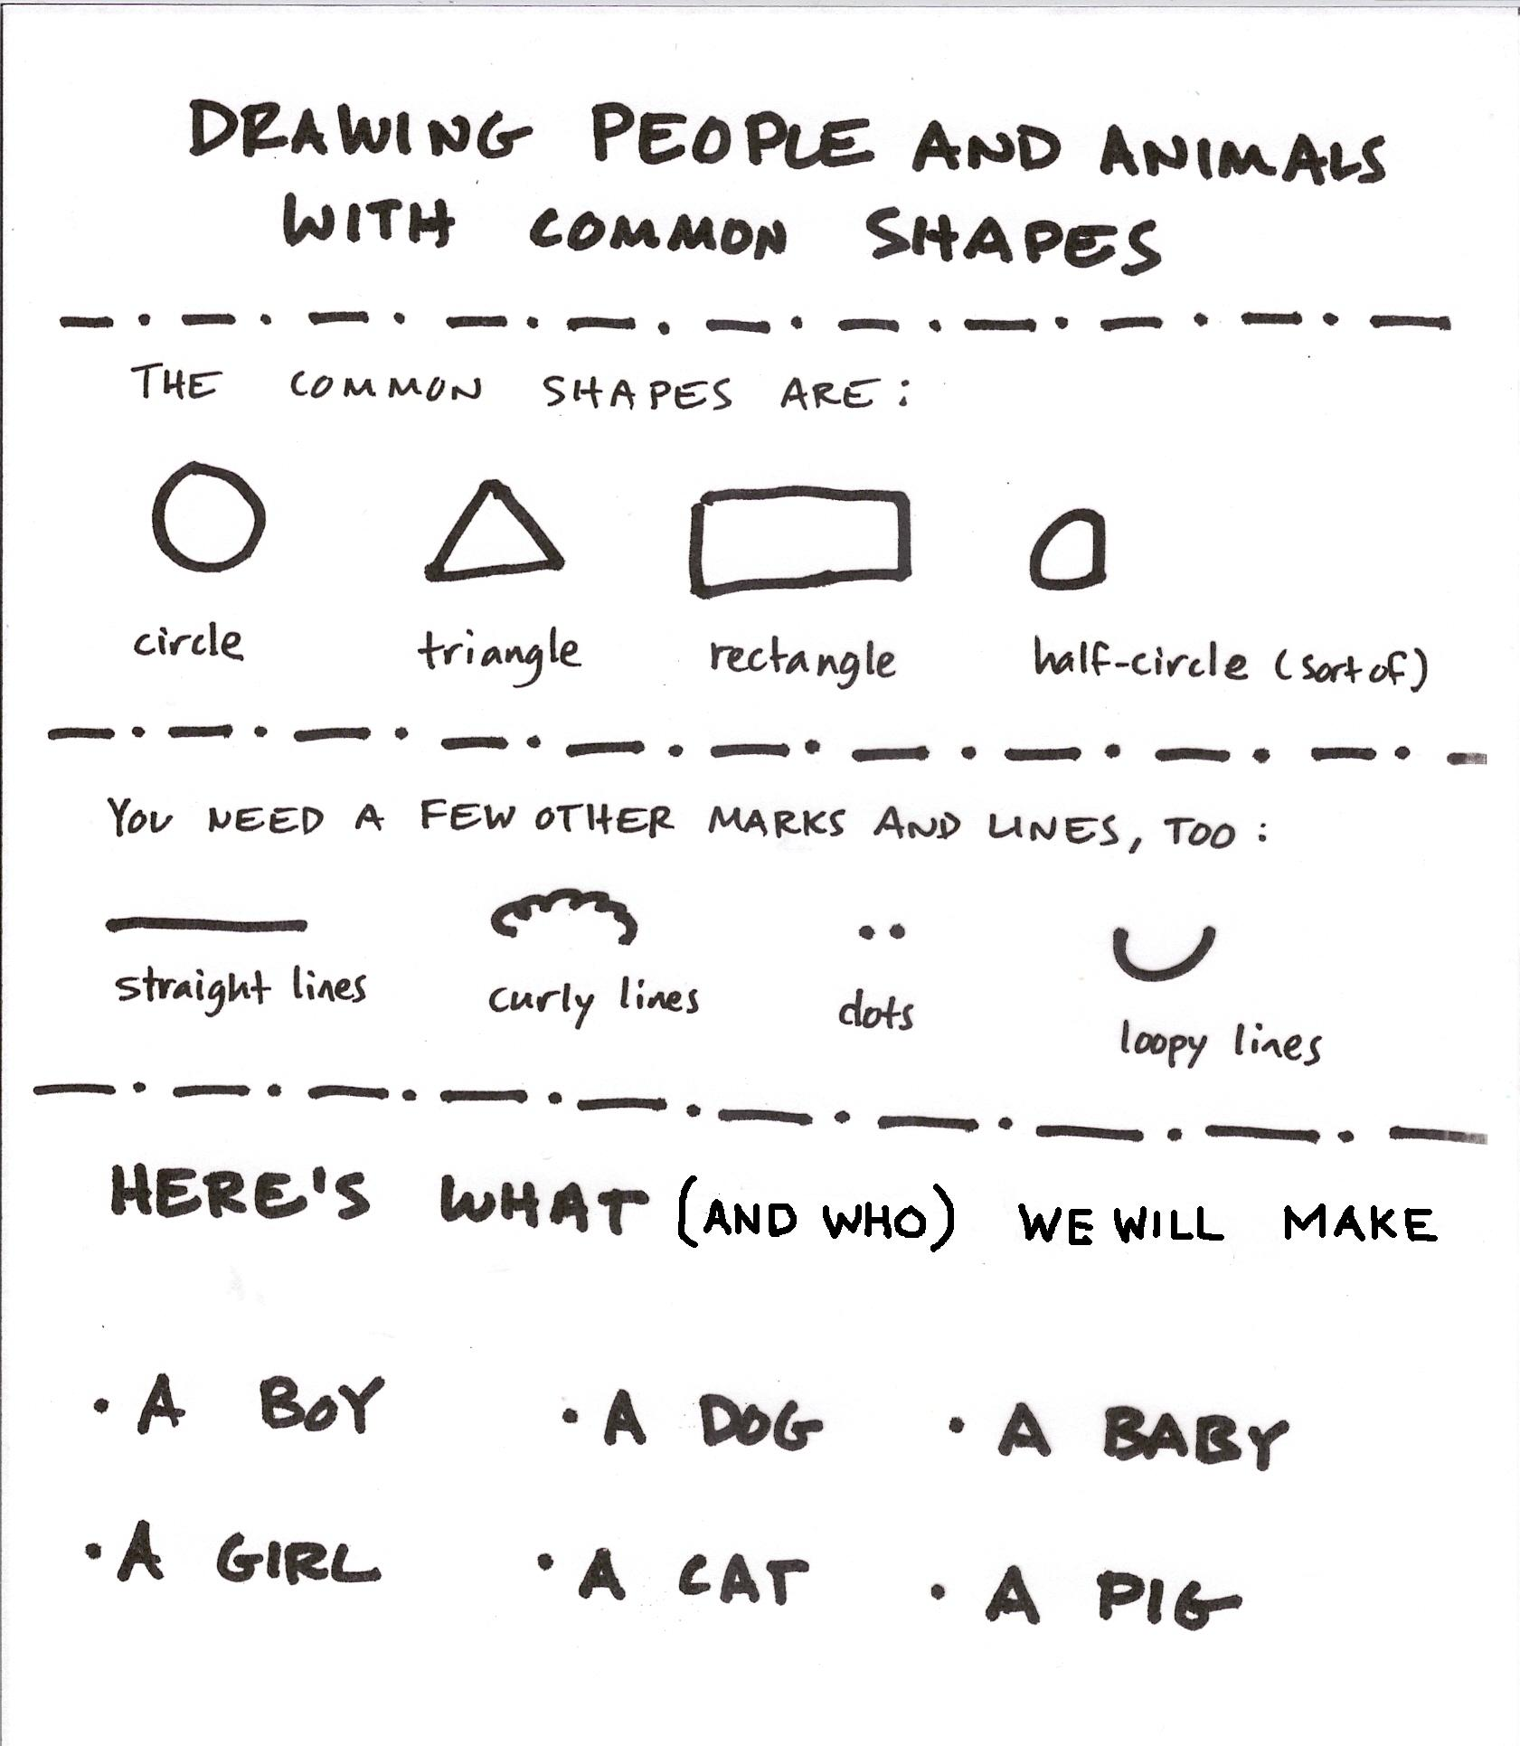

Lesson 2: Concepts of Illustration
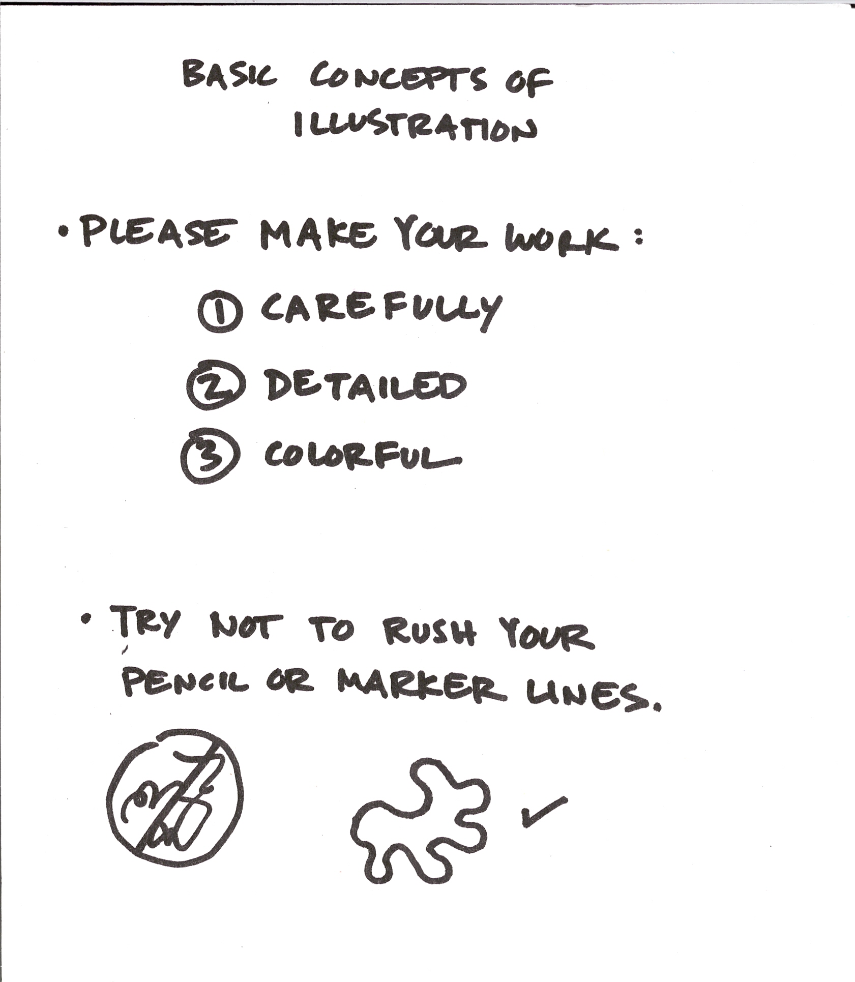

Lesson 3: The Boy (or whichever characters is the most important element in your story)
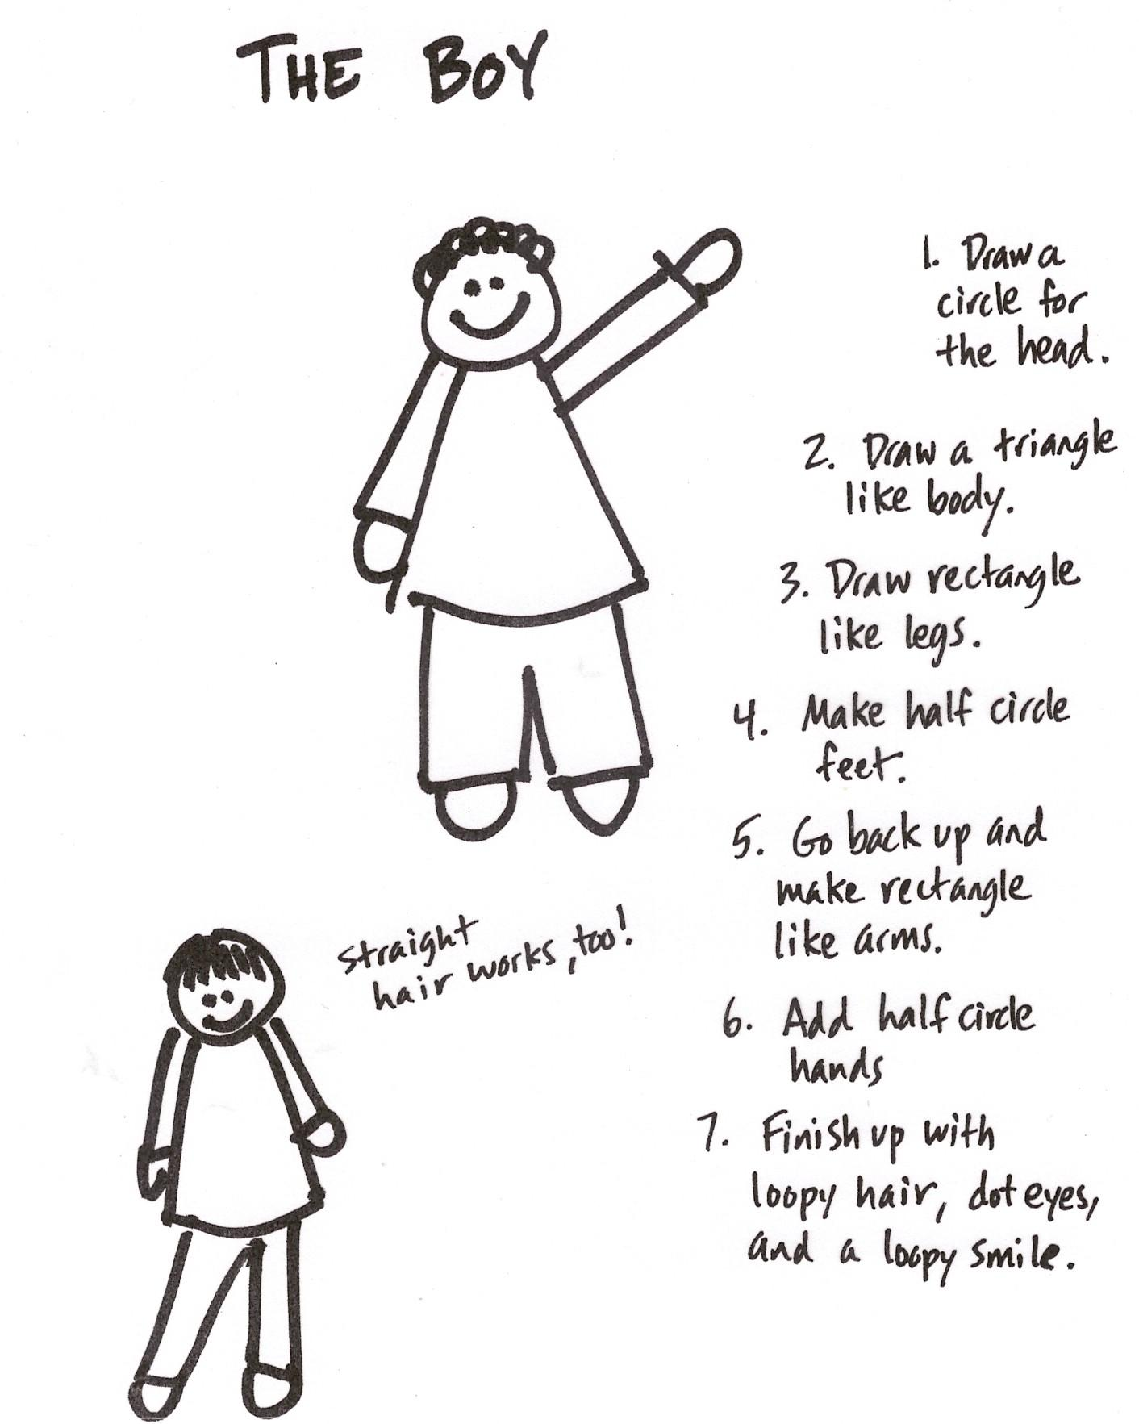

Lesson 4: The Girl (you could easily do her first)
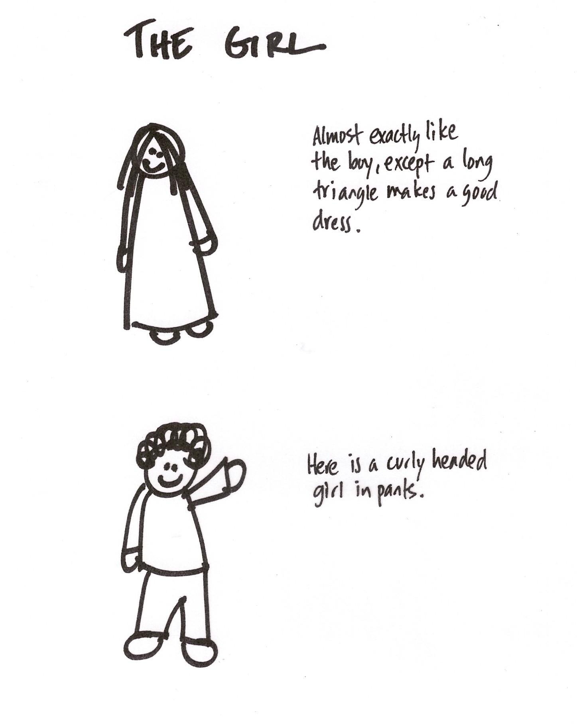

Lesson 5: Companion Animals (human’s best friends) and the Baby

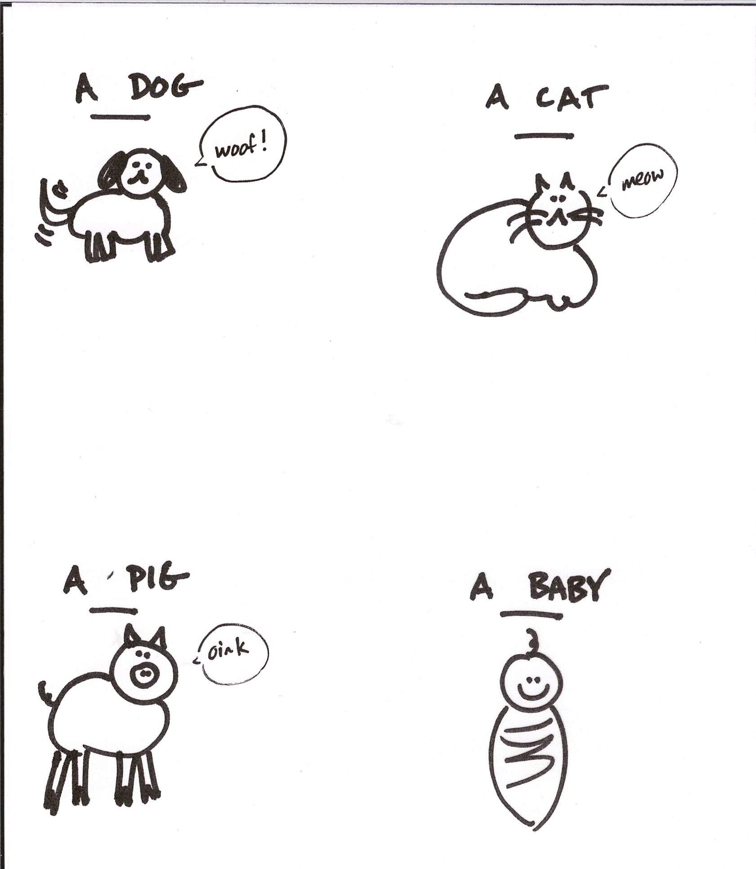

Student Examples

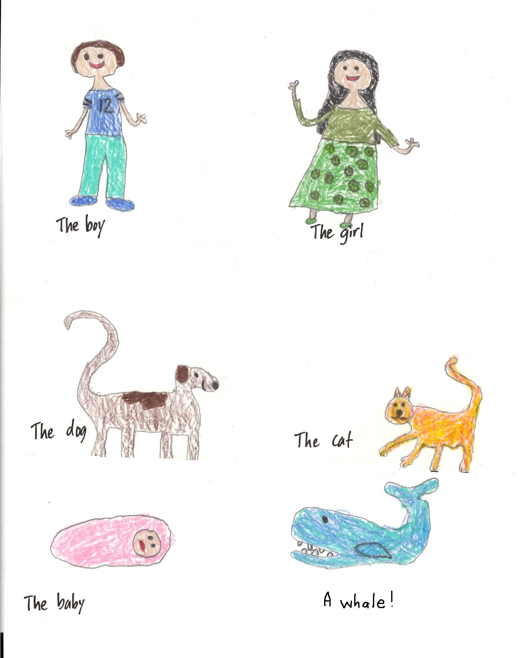

Additional Examples

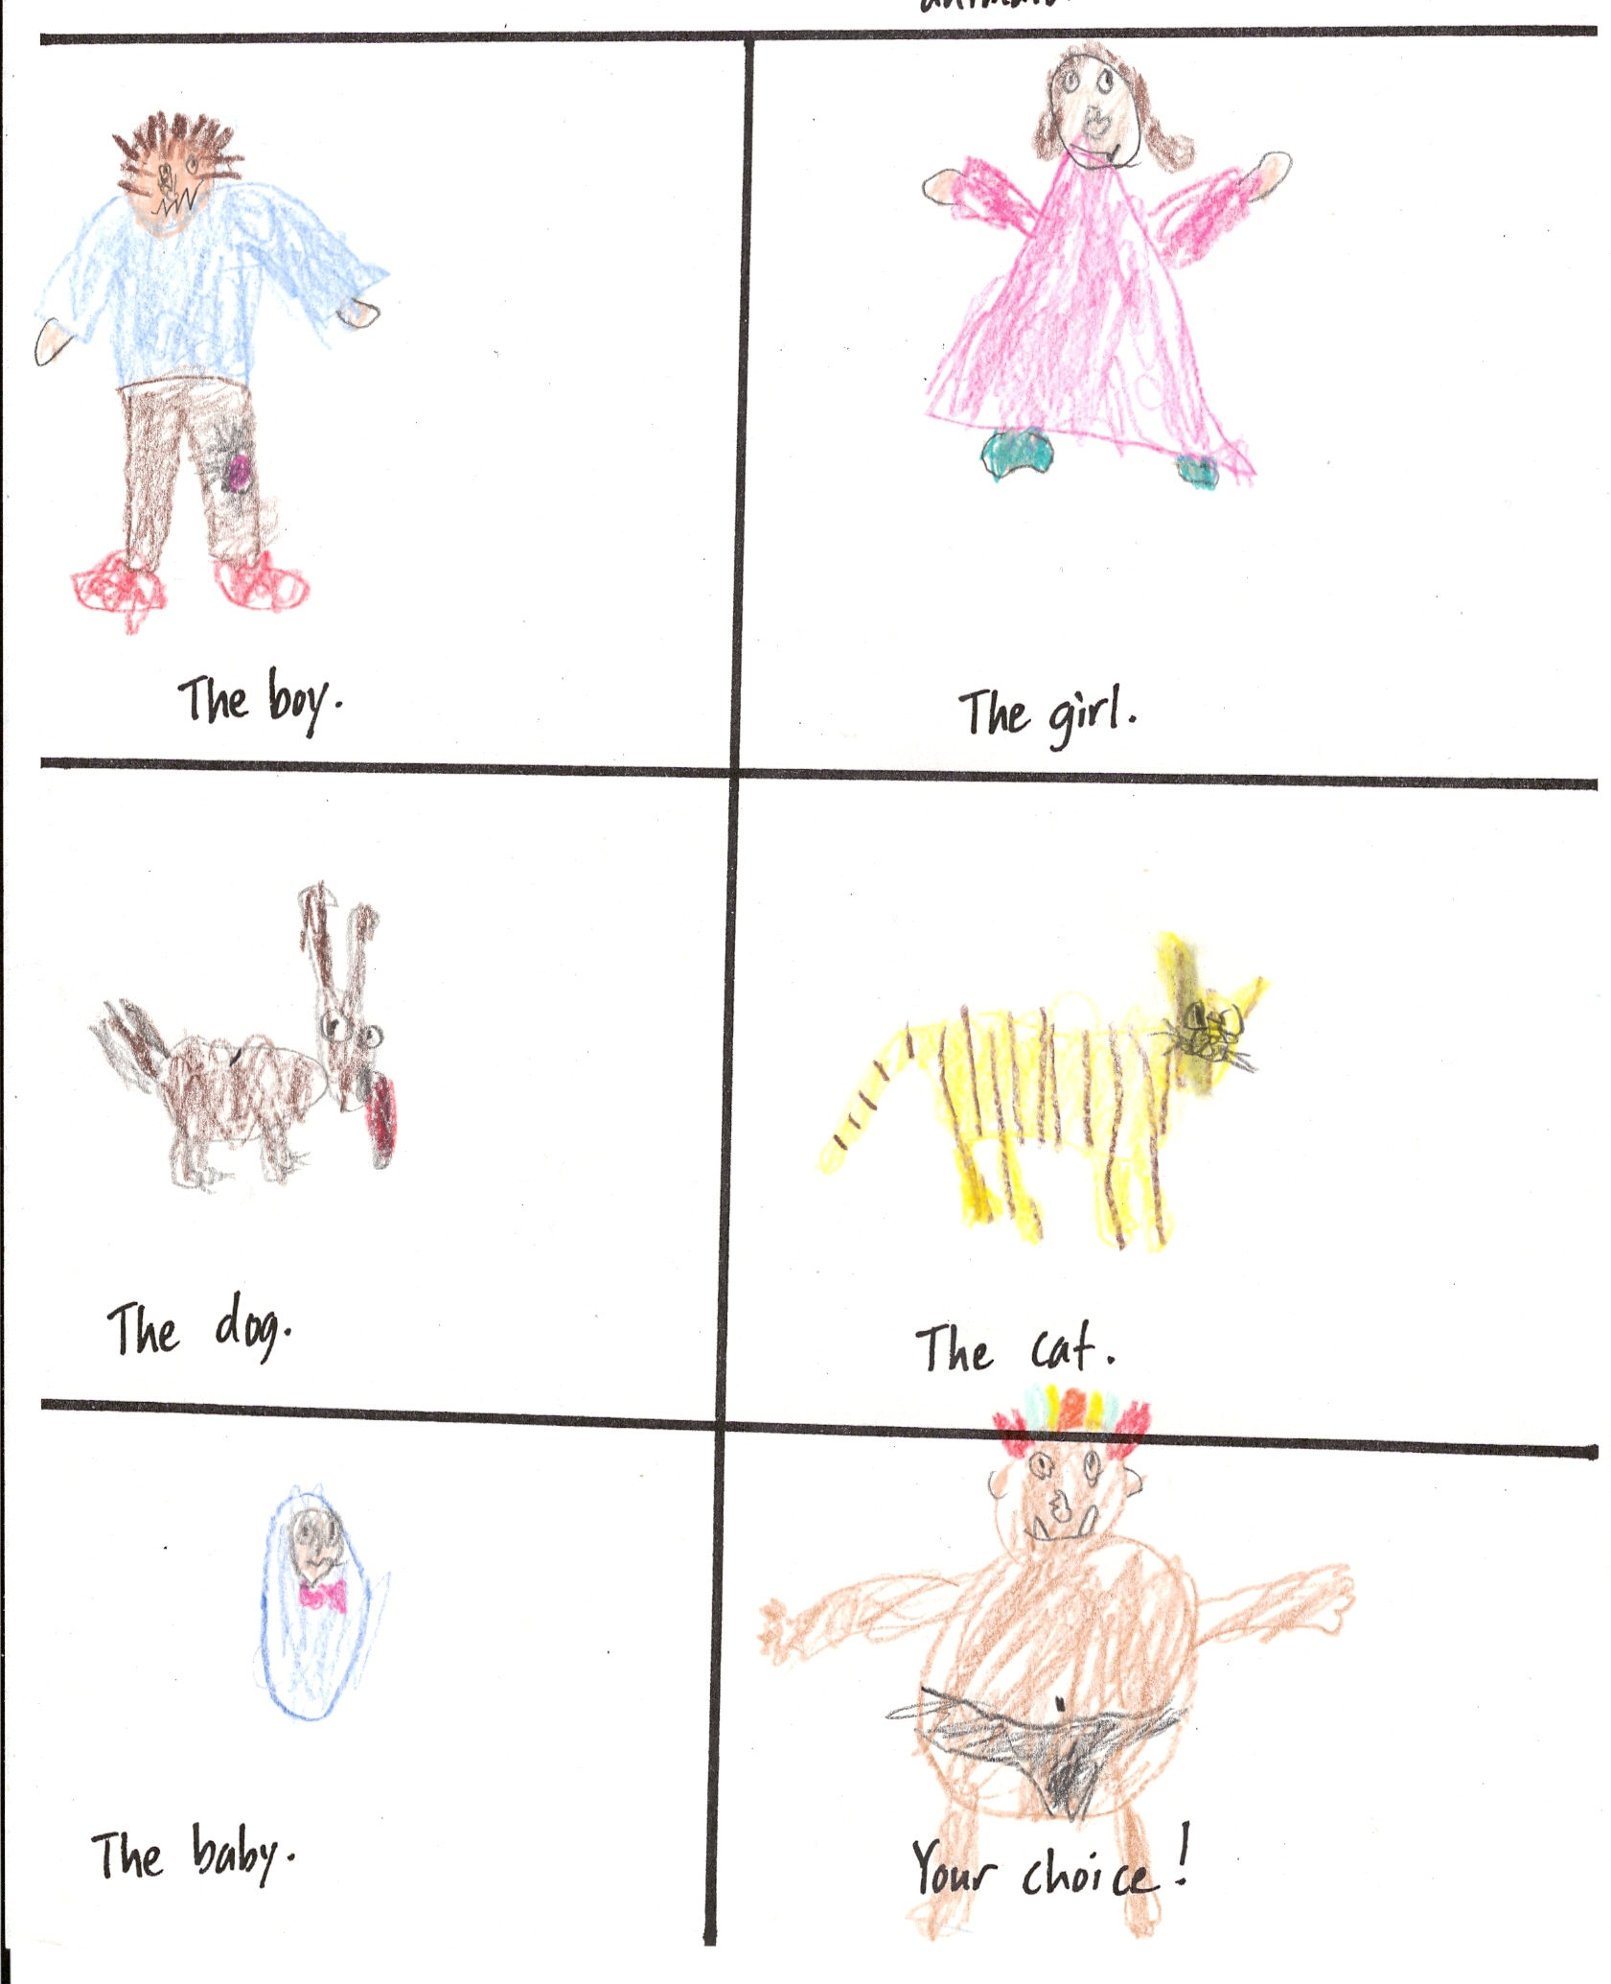

Lesson 6: Framing Landscapes

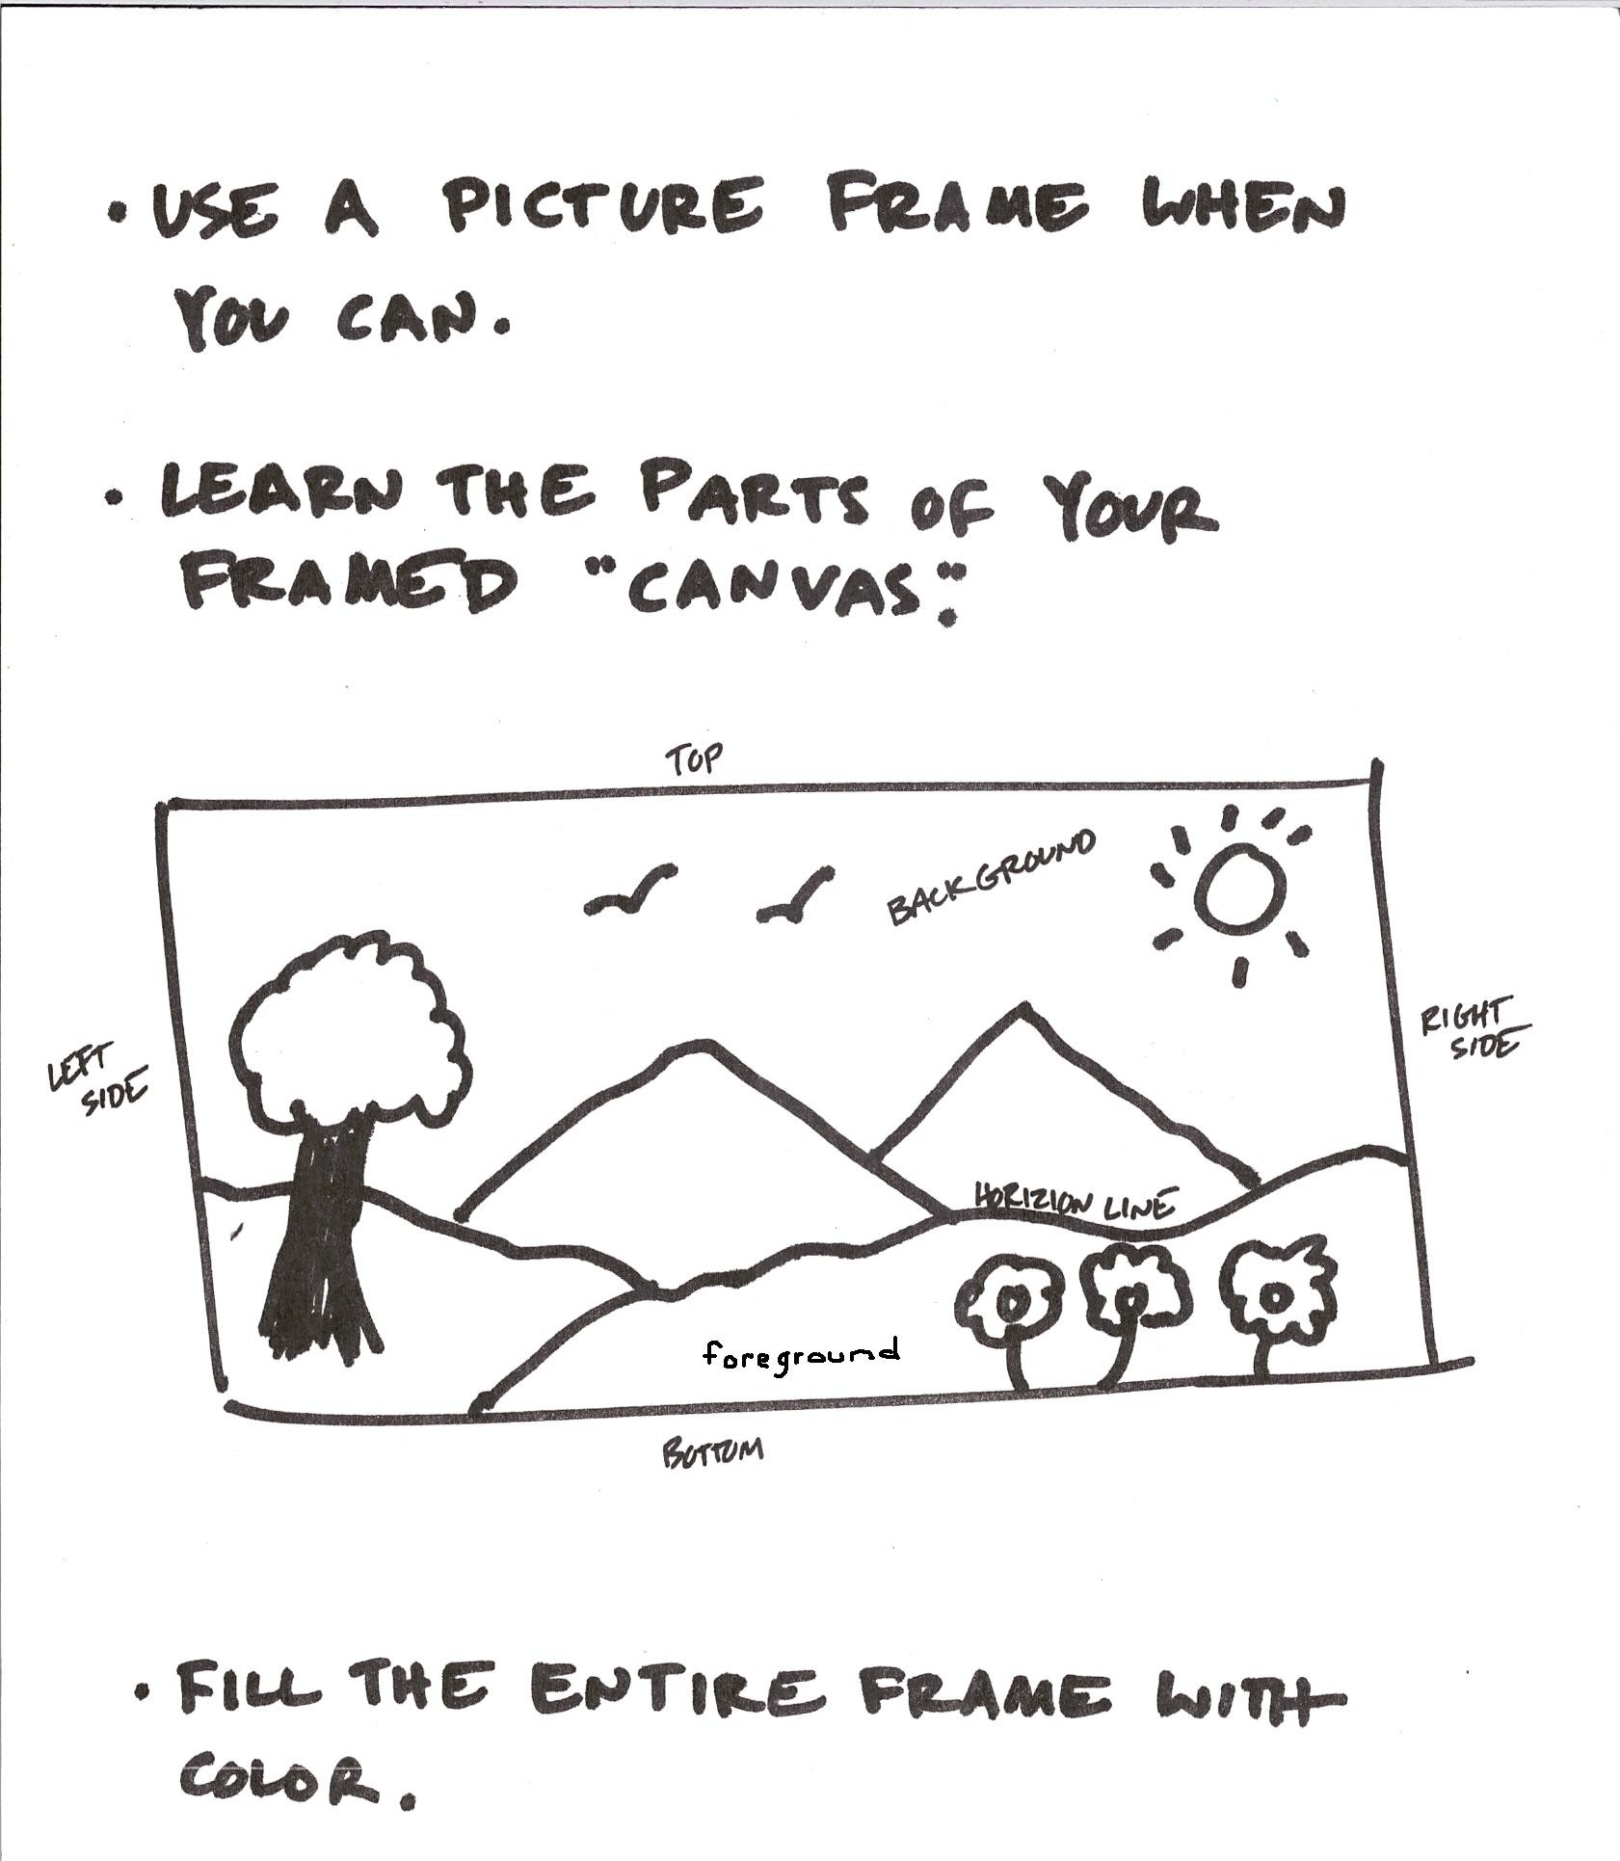

Lesson 7: Balanced Illustrations

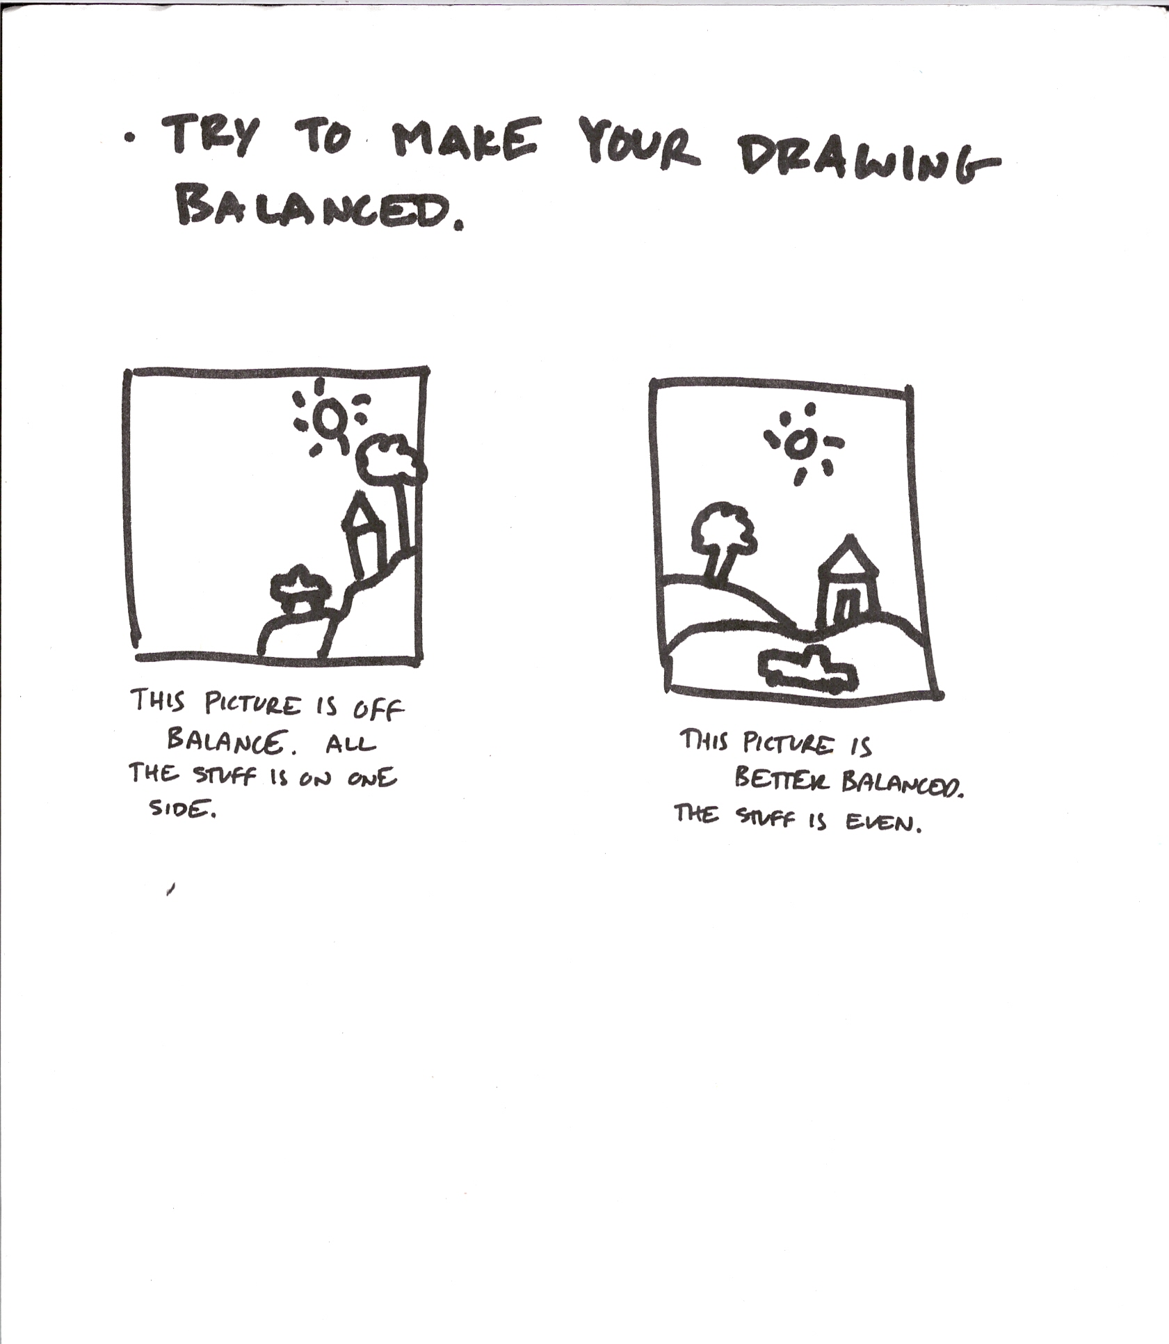

List of Additional Drawing Lessons

- Care and use of all classroom materials: crayons, stapler, correction tape, pencils, colored pencils, markers, scissors, etc.

- How to revise illustrations with correction tape
- How to revise an illustration with collage
- How to draw additional animals
- When to orient your paper landscape or portrait style
- How to animate figures: running, walking, flying, etc.
- How to draw side views
- When and why to use dialogue balloons and punctuation in illustrations

- How to ask for help with an illustration
- How to teach someone to do an illustration
- How to teach the large group to do an illustration
- What drawing tool to use for each drawing job
- Techniques with each drawing tool

